Arctic Seismic Acoustic Measurement
April 2013

Trip Report

Revision History
DATE | EDITOR | COMMENTS
05/01/2013 | Tim Wen | Document creation
05/07/2013 | Tim Wen | Addition in acknowledgement

- Introduction

On 4/6/2013 three hydrophones and four geophones were deployed at an ice floe at location 88° 53' N and 74° 43' E to record seismic signals from Gakkel Ridge at the bottom of the Arctic ocean. After drifting around for nearly 2 weeks, the 4 geophones and 1 hydrophone were recovered on 4/19. Deployment and recovery operations were staged from Ice Camp Barneo, at 89° 34' N and 144° 35' W, 164 km from the floe at the time of deployment, and 210 km at recovery.

- Recording instrumentation

The hydrophones were deployed at a nominal depth of 200m, suspended from a cable which provided power and comm. Each had a pressure logger attached at ~1m above on the cable. Geophones were deployed on the surface about 1-2m from the hydrophone hole. Two SVP buoys were deployed to provide position of the floe at regular intervals. Some information on the instrumentation is given below.

  - Hydrophones

Model: icListen LF by Ocean Sonics
Sample rate: 1000 Hz
A to D converter: 24 bit sigma delta
Data: internally logged in WAV format, a new file every minute
Power: external 24VDC

  - Pressure loggers

Model : DR-1060 by RBR
Sample rate: 1Hz
Data: internally logged
Power: internal battery

  - Geophones

Model: Reftek RT-130 Datalogger with narrowband and wideband sensors
(provided by PASSCAL Instrument Center of New Mexico Tech)
Sample rate: 500 Hz
A to D converter: 24 bit
Data: binary on compact flash card
Power: external 12VDC

  - Buoys

Model: SVP buoy by MetOcean
Data upload interval: remotely programmable

- Camp deployment

The original plan called for a 12-24 hour period deployment near the camp first to obtain some test data which would be sent back to APL for analysis. The aircraft schedule, however, was very tight, with planned arrival at Barneo on 4/4 and helo deployment flight on 4/6. This basically didn’t allow enough time for the camp deployment and subsequent data download (which would have taken ~40% of recording time). Furthermore, recovering the hydrophone probably meant cutting the cable after it froze in and therefore time was needed to re-splice it as well. The camp deployment thus didn’t look promising.

As luck would have it, our flight to Barneo was moved up a day earlier to the evening of 4/3. So on the next day, after settling in, we had time to deploy a hydrophone and a geophone. And as luck would have it again, we found a large hole about 100 m from the camp that the camp staff had dug a few days earlier for ice bath. It had refrozen with ~15cm of ice. After we chiseled through the top, we found it had a bottom layer of ice. But fortunately we were able to chisel through the bottom relatively easily.

While we were getting the hydro-hole ready, the hydrophone got cold-soaked, went dead and refused to talk to the PC. The temperature was probably only ~ -20C. We had to get another one (#2) and keep it warm long enough to go through the setup procedure. Then the PC died when its battery got cold so another one has to be brought from the camp. Finally the hydrophone was properly set up and deployed. The hydrophone was lowered to ~180m. No pressure logger was attached. A geophone (#4) with a new wideband Trillium sensor was deployed nearby. The sensor was placed in a 10”-diameter augered hole about 25cm deep, leveled and buried with snow/ice chips halfway. The total deployment effort took ~3 hours. Figures 1a & 1b show the deployment of the hardware.

We recovered the hydrophone and the geophone at 1000L the next day 4/5. The hydro-hole had only refrozen ~2-3cm and therefore the cable was easily recovered intact. The cable was simply figure-eighted and placed in a large box. Data were downloaded from both instruments and sent to APL from Longyearbyen later.

As a result of the camp deployment, we learned that things always took longer than expected, especially in the cold environment. Thus in preparing for the actual field deployment, we tried to do as much as possible ahead of time, such as connecting the geophone cables (power, GPS, signal), setting up the pressure loggers, putting in battery terminal screws, etc. to minimize the setup time in the field.

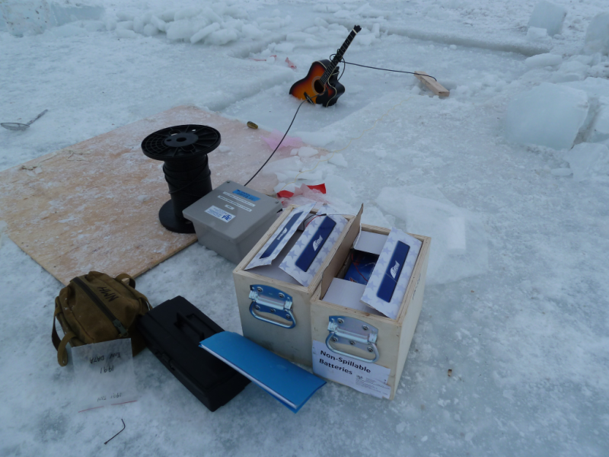
Figure 1a. Deployment of hydrophone near the camp

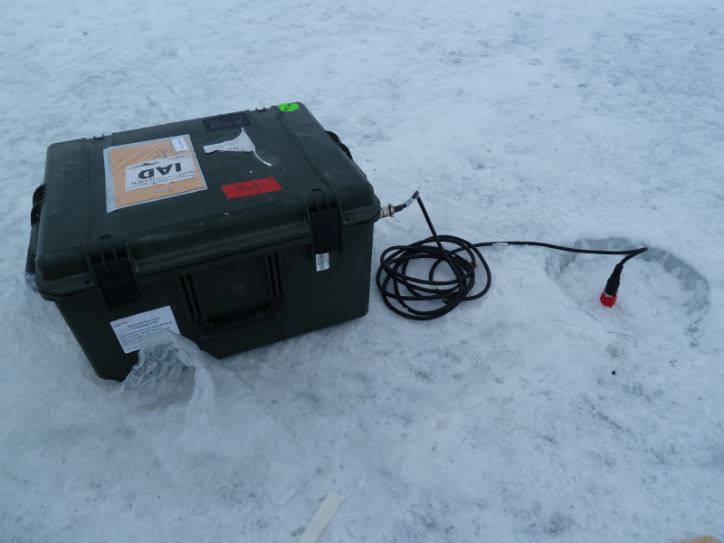
Figure 1b. Geophone deployed near the camp

- Field deployment

In the late afternoon of 4/6 we were given helicopter time to deploy the instruments. The target location was 89° 15' N and 75° 00' E. Leaving at ~1630L and after an hour of flight, we landed on a floe at 88° 52.8' N and 74° 42.8' E, 164 km from the camp.

As soon as we landed, we deployed 2 SVP buoys. They would transmit position and weather data at regular intervals and the information could be viewed on a website (https://asset.joubeh.com/asset). Since the recovery of the instruments depended on knowing the position of the ice floe later, it was essential to verify that the buoys were working. This was accomplished by calling someone at Longyearbyen via an Iridium phone to check the website and with a gizmo that detected transmission when placed near a buoy.

With the buoys working we proceeded to install the instruments. The plan was to deploy the hydrophones in a triangle roughly 100m on each side, with the helo at the center to facilitate equipment access. A team of 2 was responsible for drilling holes and laying out the cables and a second team of 2 for deploying the instruments.

Air temperature was -18C with a breeze. Ice was ~1.5 m thick. We started with hydrophone #2 first. Unfortunately it got too cold and stopped working just like back at the camp. So we fetched hydrophone #3 from the helo. Meanwhile we warmed up #2 in front of a blasto heater. We were able to establish comm with hydrophone #3 almost right away. Although the hydrophones were configured to start logging as soon as the power is applied, we opted to wait for one minute to make sure the phone was working and the data was being logged. But it seemed like an eternity waiting for it to log the first minute of data. Feeling rushed with people standing around waiting and our bare fingers freezing, we abandoned #3 and went back to #2 hyd which had warmed up sufficiently. This time we patiently waited long enough to verify the logging and deployed the hydrophone. A pressure logger was attached ~1m above the hydrophone to record depth data.

Geophones #2 and #4 were deployed at the same location. They took a long time to deploy too. #2 used a conventional sensor and #4 the new Trillium sensor. Both were set in holes ~25cm deep. The old sensor had 3 spikes which were hard to level on hard ice. So we ended up shoving some snow/ice chips in the hole and then placing the sensor over the bed and leveling it. The Trillium sensor didn’t have a built-in level and we lost the bubble level for leveling it. So we just placed it at the bottom of the hole which had a pretty flat surface. We more or less oriented the 2 sensors in the same direction. Then came the task of starting the geophone data logger. We had to go through a relatively lengthy checklist and by the end our fingers were hurting badly from the cold.

Therefore on the next 2 holes we decided to just install only the hydrophones to save time and misery. #3 was installed without a hitch. #1 took a bit longer as an ice penetrator head had to be attached to the hydrophone assembly. This was one task that should have been done back at the camp. It was not because the assembled length was ~1m and we were afraid it could be damaged during transport. We had a bit of luck with #1 as the PC died within a second after we got the initial 1-minute logging verification.

After all the hydrophones were deployed we decided there was still time to deploy the other 2 geophones. Therefore geophones #1 and #3, both using conventional sensors, were deployed with hydrophones of corresponding number.

Finally we placed SVP buoy #1 at hyd #2 location and buoy #2 at hyd #3 so that we could still track at least the 2 if the floe were to break up. The buoys were reporting their positions at 3-hour intervals at first. Fortunately they were remotely programmable and we had them changed to reporting at hourly intervals on 4/12.

The whole operation took ~4.5 hours, much longer than we anticipated. Figure 2 shows an aerial view of the 3 deployment sites.

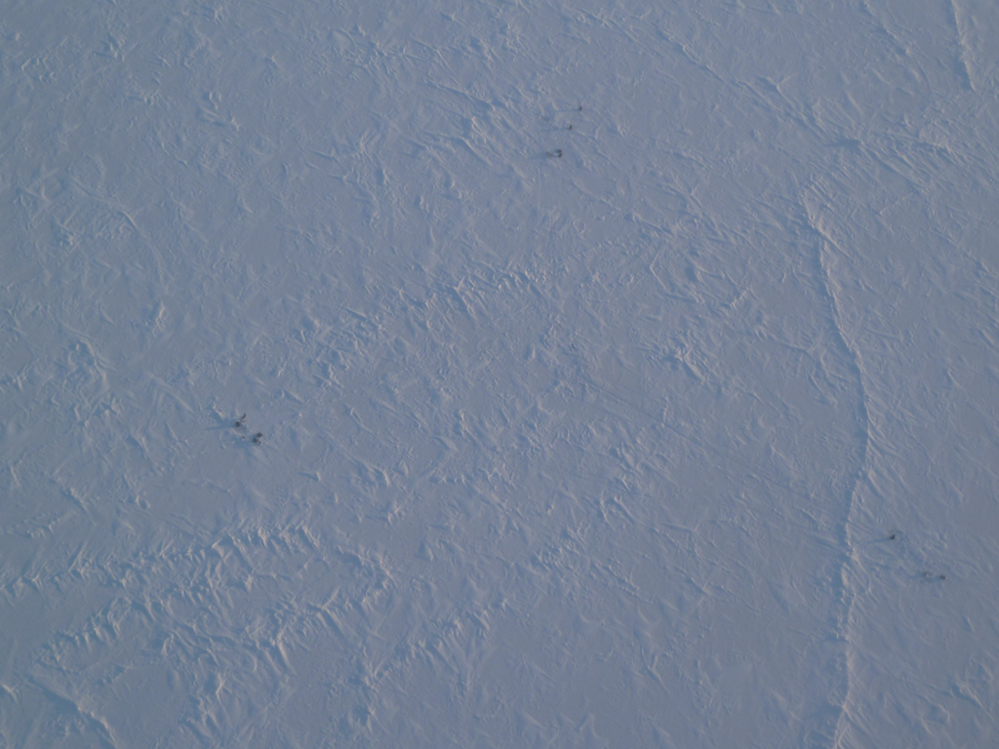
Figure 2. Aerial view of deployed instruments, CCW with #1
hydrophone at the top.

- Recovery

We were originally scheduled to recover the instruments on 4/20, but were able to do it a day earlier due to the availability of a helo.

At recovery time the floe has drifted by a significant distance since the instruments were deployed. Figure 3 shows the drift tracks of the floe and Barneo.

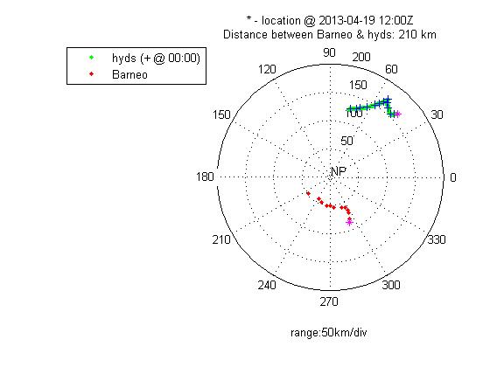
Figure 3. Drift tracks of Barneo and ice floe.
North Pole is at the center. Longitudes are shown as 0-360 (30 = 30E and 330 = 30W).

We kept track of the floe position throughout the deployment period as there was concern that it could have drifted too far from the camp for the helo to reach. The distance between Barneo and the floe was as much as 220 km at one time. And it was 210 km at the time of recovery. The helo needed an external fuel tank installed to enable it to reach the floe.

Also about a day earlier we had the SVP buoy reporting interval updated to every 15 minutes in order to have the most recent position possible. We called Longyearbyen for the latest position just prior to departure. We were also prepared to call Longyearbyen for a position update from the field in case we couldn’t find the floe after some searching.

Fortunately we found the floe without any problem, arriving at 1200L. To our amazement we saw that a pressure ridge had formed by hyd #2 (Fig 4) and a crack had run through one of the geophone sensor hole (Fig 5). There were rafted ice block underneath such that we still couldn’t drill through to the water after 2 flights of augers which totaled 2 m in length. We decided to abandon #2 for now and recover the others first.

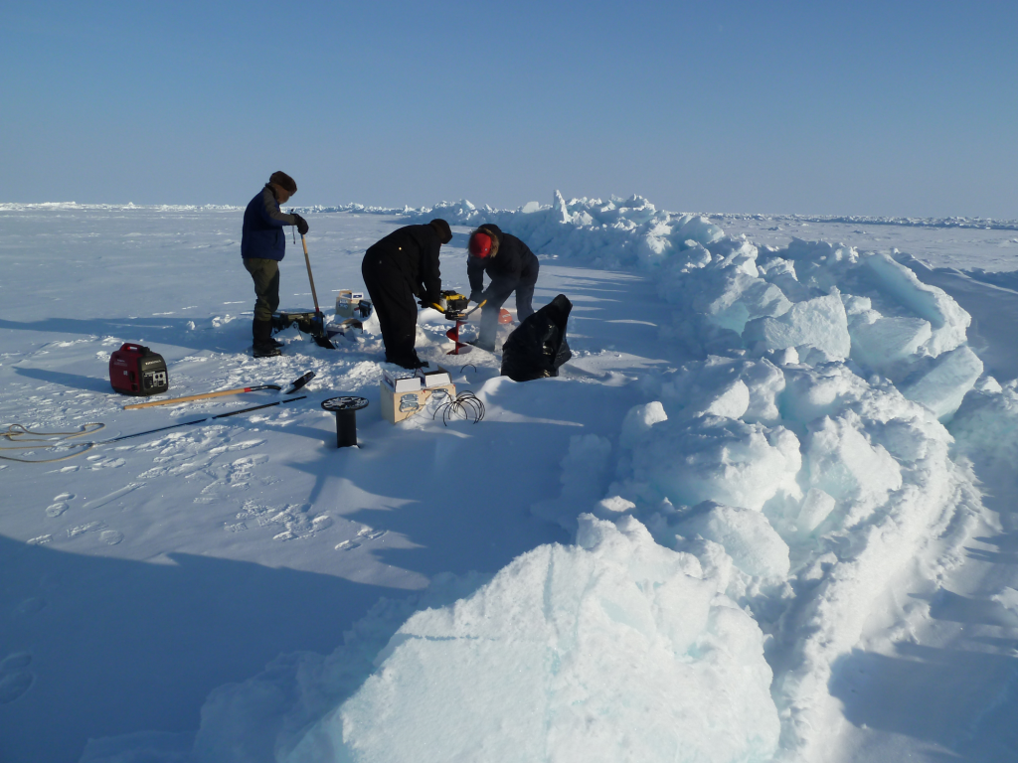
Figure 4. A pressure ridge by hydrophone #2.

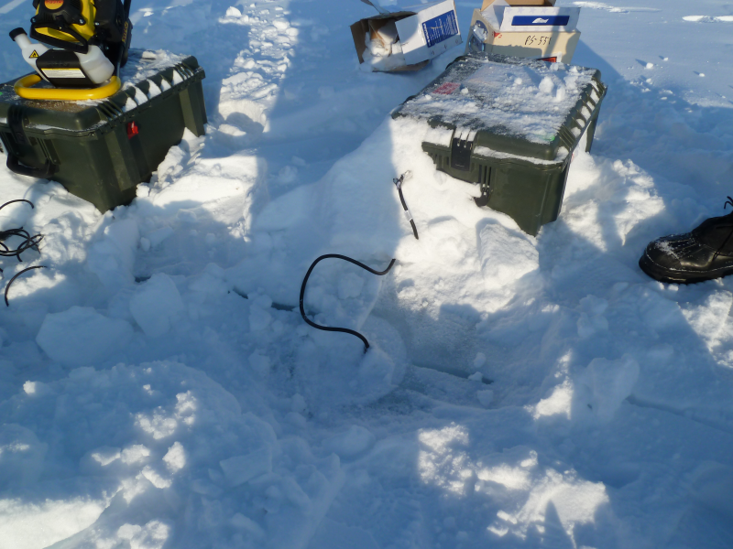
Figure 5. A crack running through geophone sensor hole

While the hydrophones were being recovered, the geophones were recovered by another team. It was found the sensors were never really frozen in and were easily recovered from the holes. A simple procedure was performed to shut down the geophone data loggers. However, during the initial excitement of recovery, geophone #2, the first one reached, was powered down without going through the shut-down procedure.

Hydrophone #3 was recovered successfully. But #1 could not be snagged with the recovery tool. The person operating the recovery tool said he felt some weight at first but then lost it. It was possible that the cable, having only a breaking strength of 25 lbs, broke under the combined weight of the penetrator and the operator pulling on it. It was also possible that the recovery hole was too close to the hydrophone hole and the auger head got too close to the cable and cut it. We augered another hole in the remote chance that we may find and snag the cable, but still came up empty.

We went back to hydrophone #2 and tried augering again, but gave up after 3 flights of auger and still hitting ice. We believed that the cable was all tangled up in the ice blocks beneath and not recoverable anyway.

Thus in the end we came back with only 1 hydrophone and its companion pressure logger, and the 4 geophones with their sensors. The hydrophone junction boxes were recovered. Cable for the #3 hydrophone was left behind intentionally. One SVP buoy was left at the floe and the second one was dropped off halfway back to the camp to continue to provide drift data to others.

The recovery operation took ~3 hours, again longer than we expected.

- Data

The pressure logger data and the geophone data were downloaded as soon as we returned to Barneo. But the hydrophone data wasn’t downloaded until it was hand-carried back to APL.

A quick look at the pressure logger data (Fig 6) shows that the #3 hydrophone was streaming at a depth as shallow as 125m at times due to floe movement. This compares relatively well with the drift speed of the floe shown in Figure 7 with matching peaks, but not in amplitude. The drift speed was computed using SVP buoy position data.

Figure 6. Plot of #3 pressure logger data, generated using RBR’s Ruskin software.
Time is in UTC.

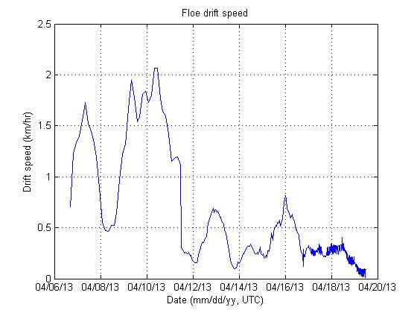
Figure 7. Floe drift speed during the deployment period

- Acknowledgement

Special thanks to the following people for making ASAM field trip a success:

John Guthrie, Andy Heiberg, Jamie Morison, Dean Stewart for in-field support,
Tom Quinn for beach support from Longyearbyen,
Ignatius Rigor for the use of SVP buoys, and
Tim Elam, Nick Michel-Hart, for pre-trip preparation and packaging of instruments.

