A short summary prepared for PASSCAL data archive

Survey name:
Rice University Shallow Seismic Surveys in Houston, 201159

PI:
Colin, Zelt. Earth Science Department, Rice University

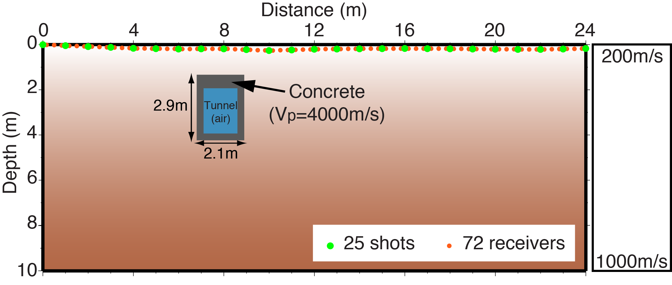

A schematic view of the 2-D survey line showing the source-receiver geometry, the known location and the compressional-wave velocity structure of the target. A known utility tunnel on Rice campus between the geology and biology buildings that is perpendicular to our surface 2-D seismic line is the target of this survey. There were 25 evenly spaced hammer shots, 1 m meter apart, and 72 channels evenly spaced along the 24m-wide-line, starting at ${29}^{°}43'09.30"N$, ${95}^{°}24'07.88"W$, ending at ${29}^{°}43'08.48"N, {95}^{°}24'07.41"W$.

We used ES-3000 seismograph (by GEOMETRICS). Each channel is set up by a two-component configuration and each component is a 40-Hz vertical component geophone. These two components are perpendicular to each other in the same plane. During acquisition, they are mounted in the way that their plane is perpendicular to the 2D survey line, and their axis of symmetry is perpendicular to the ground. Summation of these two components produces P-waves and subtraction of these two components produces SH-waves. Each trace in the archived files is a stack of 10 to enhance the signal-to-noise ratio. There are no other processing steps applied.

The known position of the concrete walls of the tunnel is indicated (2 feet thick on top, 1 foot thick on sides and bottom). Prof. Colin Zelt and his PhD student (Jianxiong Chen) are developing and testing advanced seismic imaging methods specially designed for the shallow near-surface (upper 100 m) with the hope that they can be adopted by the environmental and engineering communities that need practical, efficient and low-cost methods in terms of data acquisition and data analysis. DOE and NSF fund this research.

The file P_Wave.sgy contains the compressional waves, sorted as shot gathers. And the SH_Wave.sgy contains the horizontal shear waves, sorted as shot gathers. The sample rate is 0.25 ms and 2001 samples for each trace.

