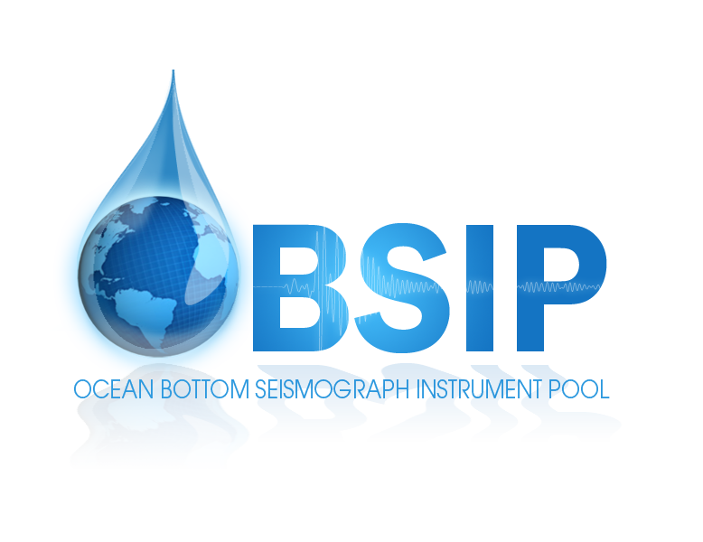

DRAFT - for OBSIP Symposium discussion

OBSIP Instrument Functional Specifications
  - OBSIP Oversight Committee
  - September 16, 2015

Broadband OBS

Science Targets
Lithospheric and asthenospheric structure; mantle dynamics; deep earth structure; earthquake studies, moment tensors etc.

Specification
- Number of instruments needed for these science targets?
- Shielding: for some, capable on others (studies of the benefits of shielding at various depths still needed)
- Trawl resistance: for trawl resistant instruments are desirable
- Clock: drift < ?? e.g. Atomic clock (Symmetricom Chip Scale Atomic Clock – CSAC)
- Flotation: Syntactic foam
- Recovery: Preferable for OBS to re-surface by acoustic release
- Recording duration: 18 months or greater at 40 sps or higher
- Clock operation duration: 24 months or greater
- Depth: 6000 meters
- Velocity transducer
  - Passband: flat to velocity from [240 or 120?] seconds to [35 or 50?] Hz.
  - Self-noise: below NLNM 100 s to 10 Hz.
  - Mass centering: Automatic motorized re-centering.
  - Bandwidth: -3dB points at 240 s and 200 Hz
  - Clip level: 26mm/s from 0.1Hz to 10Hz
- Absolute Pressure Sensor or DPG? - one or the other or both?
  - 0-10000 psia
  - Passband: flat response between 1 Hz and DC.
  - Factory calibrated.
- Datalogger
  - 4 channels minimum BB + APG/DPG (may be interest in strong motion sensor, temperature etc. also), at ~130 dB dynamic range (to accommodate additional 3-component sensor e.g., accelerometer)
  - Anti-aliasing FIR filter. Double Precision FIR Filter Causal/Acausal; >140 dB attenuation at output Nyquist
  - Record and communicate multiple sample rates.
  - Sampling rates: 1, 10, 20, 50, 100, 200, 250, 500, 1000 sps
  - Each channel can be configured independently.
  - Multiple data formats and telemetry protocols.
  - Frequency response: DC to 80 Hz @ 200 sps.
  - Acquisition modes: Continuous, triggered, time windows
  - Timing: Accuracy: <1 microseconds of UTC with GPS
  - Power: Low power consumption: <100mW (active)
- Data delivery requirement:
  - DMC: SEED

Long-term short-period OBS

Science Targets
Seismotectonics of plate boundaries, earthquakes, microseismicity experiments: hydrothermal processes, magmatic processes, mid-crustal activity, subduction zones. Seafloor volcano activity.

Specification
- Number of instruments needed for these science targets?
- Clock: drift < ?? (Symmetricom Chip Scale Atomic Clock – CSAC)
- Flotation: Syntactic foam
- Recovery: Preferable for OBS to re-surface by acoustic release
- Recording duration: 18 months or greater at 250 sps or higher
- Clock operation duration: 24 months or greater
- Depth: 6000 meters
- Three-component seismometer with [1-4.5 Hz][modular?] natural frequency
- Hydrophone or Absolute Pressure Sensor - both?
- Datalogger - same as Broadband datalogger
- Data delivery requirement:
  - End of cruise: SEGY
  - DMC: SEED and SEGY

Active-source short-period OBS

Science targets
Short-term rapid deployment pool; cheap so can have large numbers
Can deploy 100 off any regional class vessel

Specification
- Number of instruments needed for these science targets?
- Clock: Temperature-controlled clock, maximum drift < 0.5msec/day before correction.
- Recovery: OBS must re-surface by acoustic release, without the use of an ROV. Upon release, rise rate in water 45 meters/minute, 60 m/min would be preferable. Recovery aids: Strobe and radio beacon.
- Recording duration: 2 months at 500 sps or higher
- Clock operation duration: 3-4 months or greater
- Depth: 6000 meters
- Sensors
  - Self-gimballing seismometer package.
  - Three-component seismometer with 4.5 Hz natural frequency
  - Hydrophone
- Datalogger
  - Four channels (three seismometers and a hydrophone)
  - Anti-aliasing filter.
  - Sampling rates can be programmed before deployment: 100, 200, 250, 500, 1000 sps
  - 24-bit data logger.
  - Acquisition modes: Pre-programmed time windows
- Data delivery requirement:
  - End of cruise: SEGY
  - DMC: SEED and SEGY

